JOB HAZARD ANALYSIS (JHA)
This document has been designed to satisfy the requirements of the Qld Coal Mining Safety and Health Act and Guidance Note QGN 17 Development of Effective Job Safety Analysis.
SECTION 1: Provide details of the JHA task
JHA Title |  | Work Area Location
JHA Date |  | JHA Review Date(s)
Day Shift ERT Members |  | Night Shift ERT Members
Supervisor Name |  | Supervisor Signature

SECTION 2: Enter details of the work environment for the task (i.e.) Location, Equipment, Weather, Environment

SECTION 3: In simple and clear terms, describe how the task will be conducted

STEP 4: Review and Tick all Mandatory Safety Questions
Is special authorisation(s) required to undertake this job? | ☐ Yes | ☐ No | Is anyone Working Alone during this job? | ☐ Yes | ☐ No
Does this job require a Permit? (e.g.) Lifting Permit | ☐ Yes | ☐ No | Is task specific PPE required? (e.g.) Fall Arrest Equipment | ☐ Yes | ☐ No
Does the task require specialised tools/equipment? | ☐ Yes | ☐ No | Is specialised emergency equipment or personnel required? | ☐ Yes | ☐ No
List specific controls for any questions that are answered YES in SECTION 7

SECTION 5: List documents titles relevant to the task (e.g.) VUL-SOP-072e-Lifting Operations; VUL-MOP-094.1(b)Housekeeping; VUL-FRM-19-15-Lifting Permit
6.

SECTION 6: Review and Tick those Events associated with the task that may cause harm or equipment damage
☐ Fitness for Work | ☐ Working Alone / Supervision | ☐ Contractor Management (e.g.) Sub-Contractors new to site
☐ Dust | ☐ Geo-Technical including Ground Conditions | ☐ Trenching
☐ Noise | ☐ Explosives | ☐ Work Area Design (e.g.) Access, LV Parking etc.
☐ Heat | ☐ Vehicle Interaction (e.g.) vehicle/pedestrian etc. | ☐ Inadequate Emergency Access
☐ Vibration | ☐ Uncontrolled Movement | ☐ Nearby Works
☐ Biological Hazards (e.g.) bodily matter, flora, fauna, waste | ☐ Electrical | ☐ Lighting
☐ Flammable or Toxic Gas including ‘Spon Com’ | ☐ Stored Energy | ☐ Working in or around Bodies of Water
☐ Hazardous Substances | ☐ Lifting and Moving Loads | ☐ Tyres and Rims
☐ Radiation | ☐ Confined Space | ☐ Infrastructure or Equipment Failure
☐ Thermal (i.e.) Exposure to Fire or an Ignition Source | ☐ Fall from Height (i.e.) Work at Heights | ☐ Abrasive Blasting
☐ Manual Handling | ☐ Rotating Equipment | ☐ Unexpected release of fluids above or below  atmospheric pressure
☐ Line of Fire | ☐ Falling Objects / Drop Zones | ☐ Weather

SECTION 7: Complete the Risk Assessment
Risk is the potential of person harm or equipment damage arising out of a hazard
- measured in terms of consequence and likelihood
  - what is the potential consequence?
  - what is the likelihood of the consequence occurring?

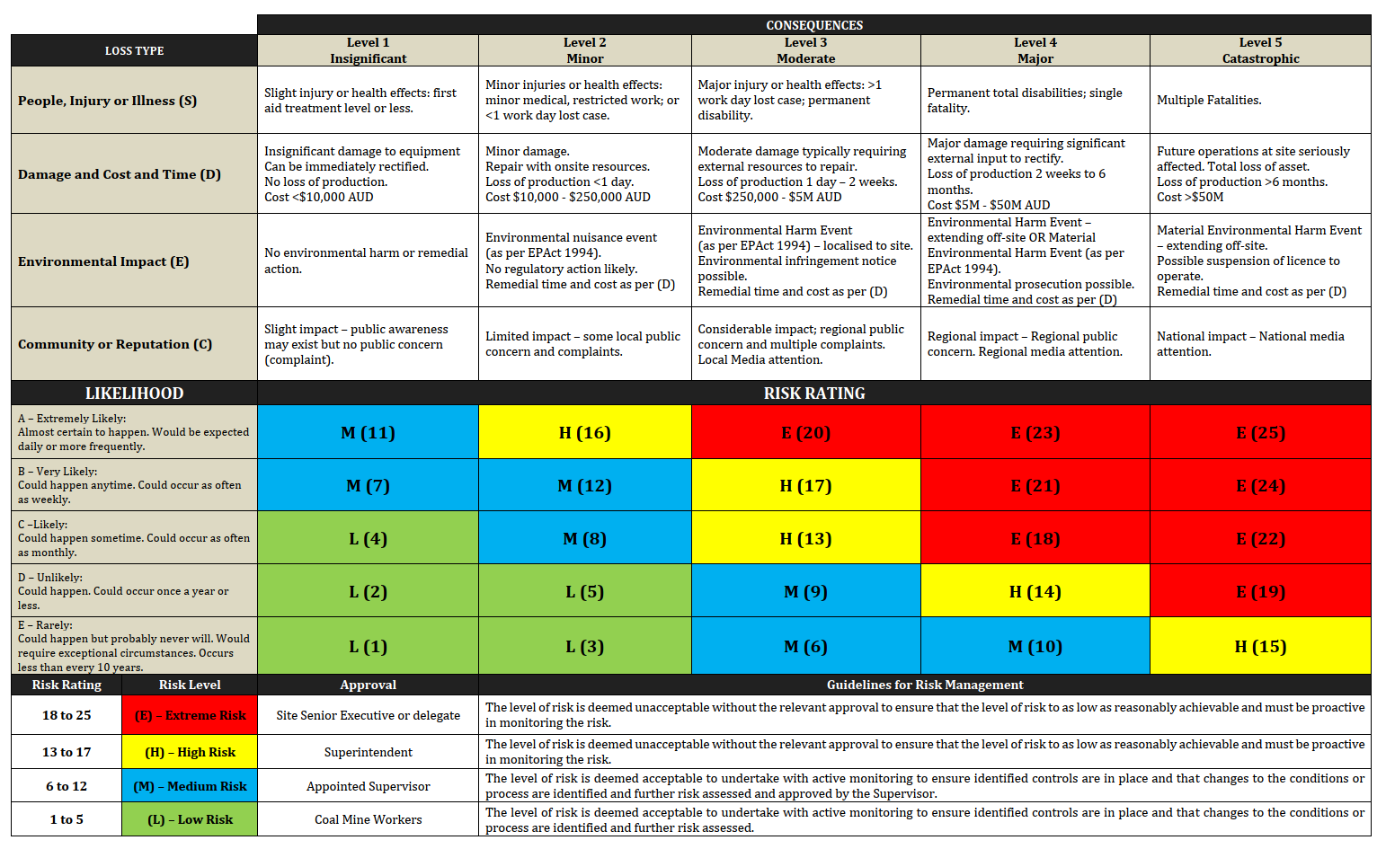

Job Step  # | Job Step Details  List the order and details of each step to be followed to safely complete the task. | Potential Hazard  List items and situations with the potential to cause personal harm or equipment damage. | Preventative Controls  List controls used to mitigate the risk for the Job Step. | Risk Rating  with Preventative Controls in place. |  |  | Additional Controls  List any Additional Controls that will reduce the level of risk for the Job Step to ‘As Low As Reasonably Achievable’ (ALARA) | Residual Risk Rating  with Additional Controls in place.
 |  |  |  | C | L | R |  | C | L | R
Job Step  # | Job Step Details  List the order and details of each step to be followed to safely complete the task. | Potential Hazard  List items and situations with the potential to cause personal harm or equipment damage. | Preventative Controls  List controls used to mitigate the risk for the Job Step. | Risk Rating  with Preventative Controls in place. |  |  | Additional Controls  List any Additional Controls that will reduce the level of risk for the Job Step to ‘As Low As Reasonably Achievable’ (ALARA) | Residual Risk Rating  with Additional Controls in place.
 |  |  |  | C | L | R |  | C | L | R
Job Step  # | Job Step Details  List the order and details of each step to be followed to safely complete the task. | Potential Hazard  List items and situations with the potential to cause personal harm or equipment damage. | Preventative Controls  List controls used to mitigate the risk for the Job Step. | Risk Rating  with Preventative Controls in place. |  |  | Additional Controls  List any Additional Controls that will reduce the level of risk for the Job Step to ‘As Low As Reasonably Achievable’ (ALARA) | Residual Risk Rating  with Additional Controls in place.
 |  |  |  | C | L | R |  | C | L | R

SECTION 8: Site Appointed Supervisor and Cross-section involved in the development of the JHA
# | Full Name | Signature | Position | Date
 |  |  | Site Appointed Supervisor

SECTION 9: All persons working on the task are to Review and Sign the JHA
# | Full Name | Signature | Date | # | Full Name | Signature | Date
Signing onto this JHA indicates persons have read and understood the safety requirements of this task.

# | Full Name | Signature | Date |  | # |  | Full Name |  | Signature | Date
Signing onto this JHA indicates persons have read and understood the safety requirements of this task.
SECTION 10: JHA Review
Has the proposed work area been assessed by the Supervisor and cross-section of the work group as part of the JHA development process? |  |  |  | ☐ Yes |  | ☐ No |  | The Site Appointed Supervisor and cross-section should inspect and assess the proposed work area for hazards when developing a JHA.
Has an (adequate) cross-section of those involved in the task participated in developing the JHA? |  |  |  | ☐ Yes |  | ☐ No |  | Ensure the Site Appointed Supervisor, additional workers and personnel experienced with the task, participate in the development of the JHA.
If the task being undertaken is in an active mining area, has the OCE been involved in the JHA process? |  |  |  | ☐ Yes |  | ☐ No |  | If No, the OCE must be part of the cross-section involved in the development of the JHA and sign-on as per SECTION 8.
Has the Shift ESO been involved in the development of the JHA, if the task is ‘high risk’ or requires a ‘rescue plan’(e.g.) Confine Space etc. |  |  |  | ☐ Yes |  | ☐ No |  | If No, the Shift OCE must be part of the cross-section involved in the development of the JHA and sign-on as per SECTION 8.
Has the cross-section that participated in developing the JHA signed All persons working on the task have Reviewed and Signed the JHA? |  |  |  | ☐ Yes |  | ☐ No |  | If No, the JHA shall not be submitted for approval until all personnel have reviewed and signed.
Have all persons working on the task, including the cross-section involved with the development of the JHA, signed SECTION 9? |  |  |  | ☐ Yes |  | ☐ No |  | All personnel who will be involved in the task, are to review and sign the JHA as per SECTION 9.  The work group cross-section involved in developing the JHA are required to sign both SECTION 8 and SECTION 9
Has at least one Extreme Risk, High Risk or Medium Risk been identified in the JHA? |  |  |  | ☐ Yes |  | ☐ No |  | If Yes, prior to submitting for ‘Final JHA Approval Sign-off’, additional controls shall be considered to further reduce the risk level to ‘As Low As Reasonably Achievable’ (ALARA).

SECTION 11: Final JHA Approval Sign-off

Site Appointed Supervisor
Superintendent/Manager
SSE/Delegate
Risk Rating Approval Requirements

Risk Score | Approval | Name | Signature | Date
At Least One Extreme Risk Identified | SSE/Delegate
At Least One High Risk Identified | Superintendent/Manager
Only Low Risks Identified | Site Appointed Supervisor
At Least One Moderate Risk Identified | Site Appointed Supervisor

